COMPUTER HOMEWORKS ON POINTERS

**APRIL 30**

PART 1

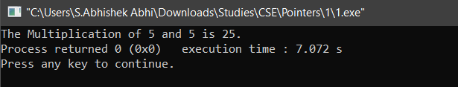

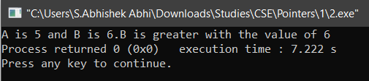

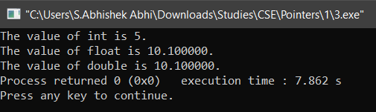

PART 2

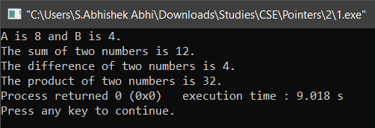

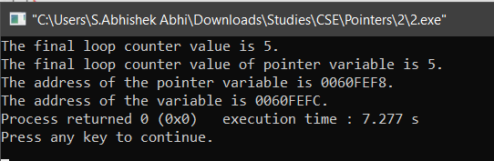

PART 3

